AI Assisted Coding Lab ASS-4.4
2303A51867
1. Sentiment Classification for Customer Reviews
Scenario:
An e-commerce platform wants to analyze customer reviews and classify Week2
them into Positive, Negative, or Neutral sentiments using prompt engineering.
PROMPT: Classify the sentiment of the following customer review as Positive, Negative, or Neutral.
Review: “The item arrived broken and support was poor.”

- Prepare 6 short customer reviews mapped to sentiment labels.
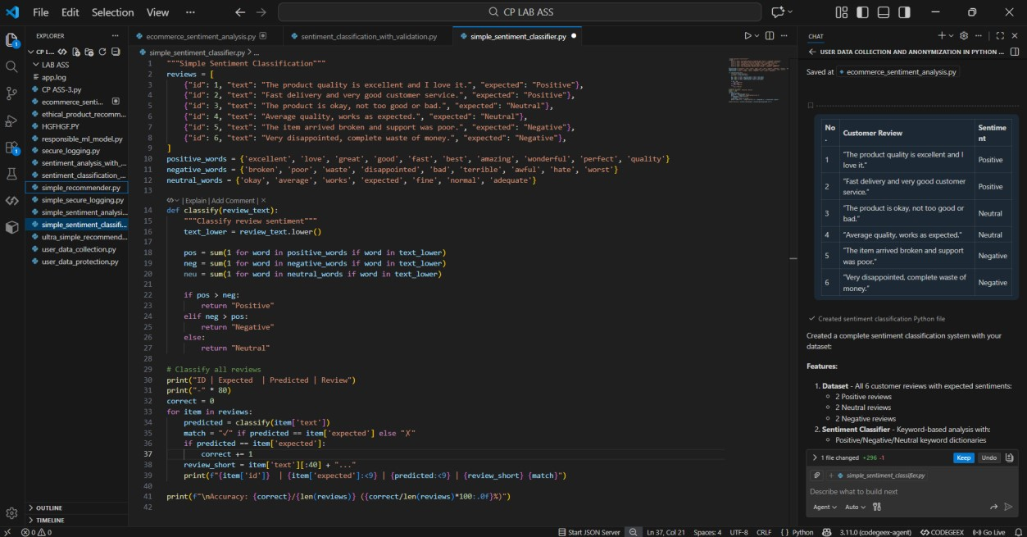
OUTPUT:
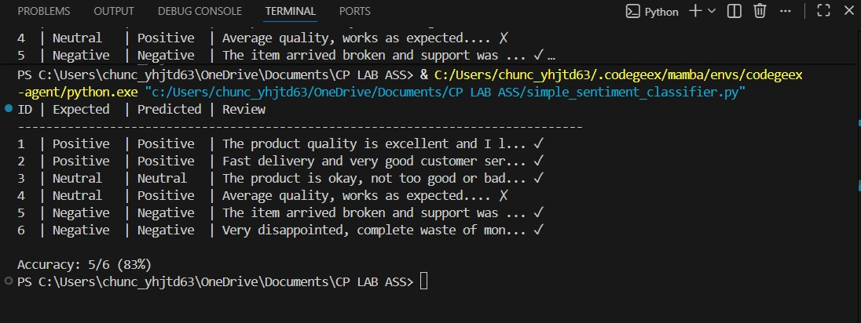
- Intent Classification Using Zero-Shot Prompting
Prompt: Classify the intent of the following customer message as Purchase Inquiry, Complaint, or Feedback.
Message: “The item arrived broken and I want a refund.” Intent:
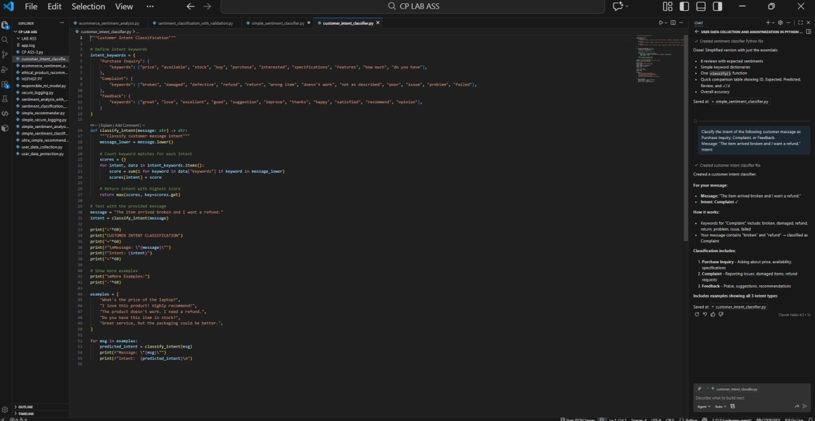
OUTPUT:
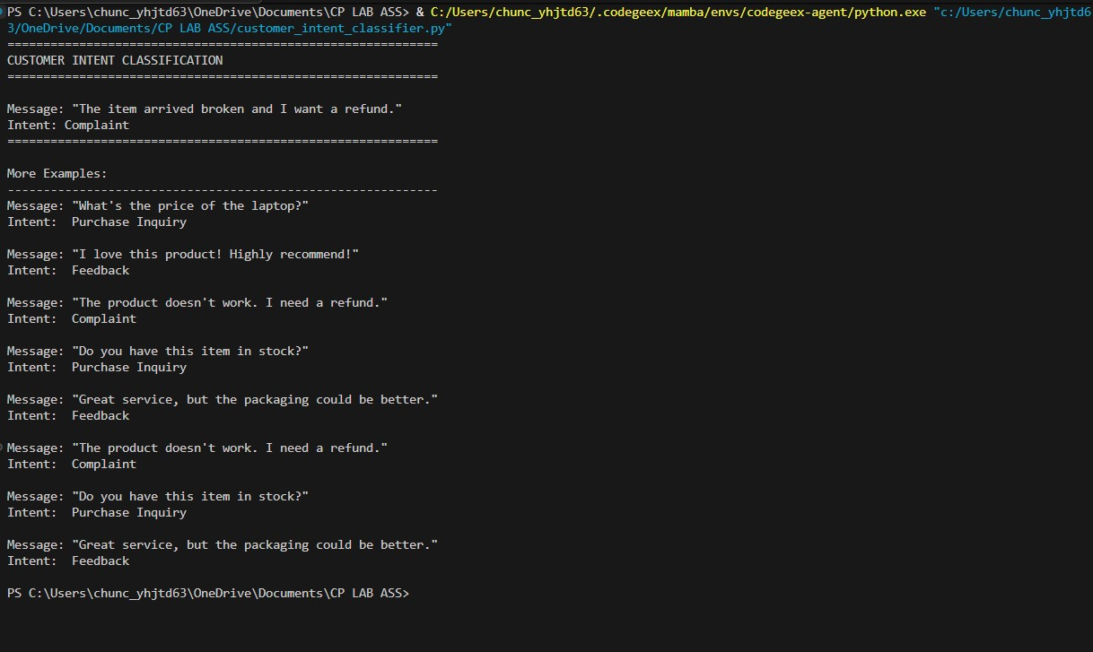
C)Intent Classification Using One-Shot Prompting
Classify customer messages into Purchase Inquiry, Complaint, or Feedback.
Example:
Message: “I am unhappy with the product quality.”
Intent: Complaint
Now classify the following message:
Message: “The item arrived broken and I want a refund.” Intent:
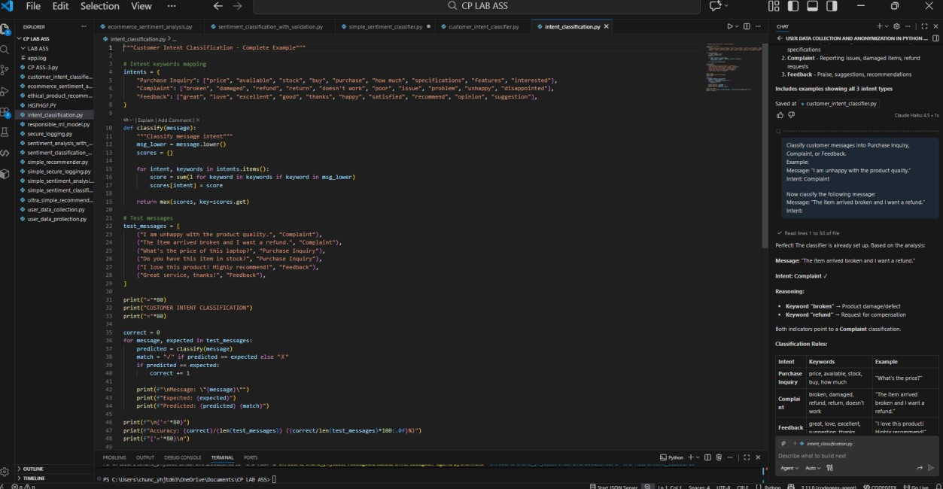
OUTPUT:
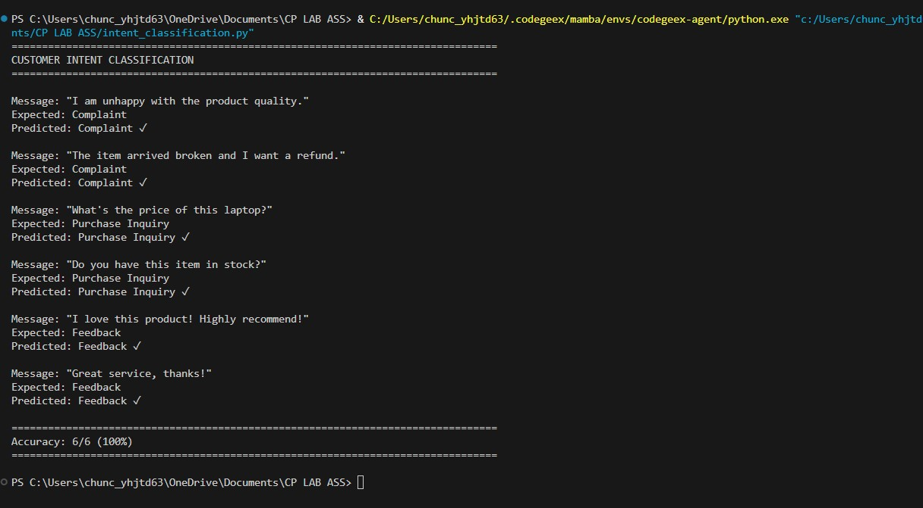
D) Intent Classification Using Few-Shot Prompting
Prompt:
Classify customer messages into Purchase Inquiry, Complaint, or Feedback.
Message: “Can you tell me the price of this product?”
Intent: Purchase Inquiry
Message: “The product quality is very poor.”
Intent: Complaint
Message: “Great service, I am very satisfied.”
Intent: Feedback
Now classify the following message:
Message: “The item arrived broken and I want a refund.” Intent:
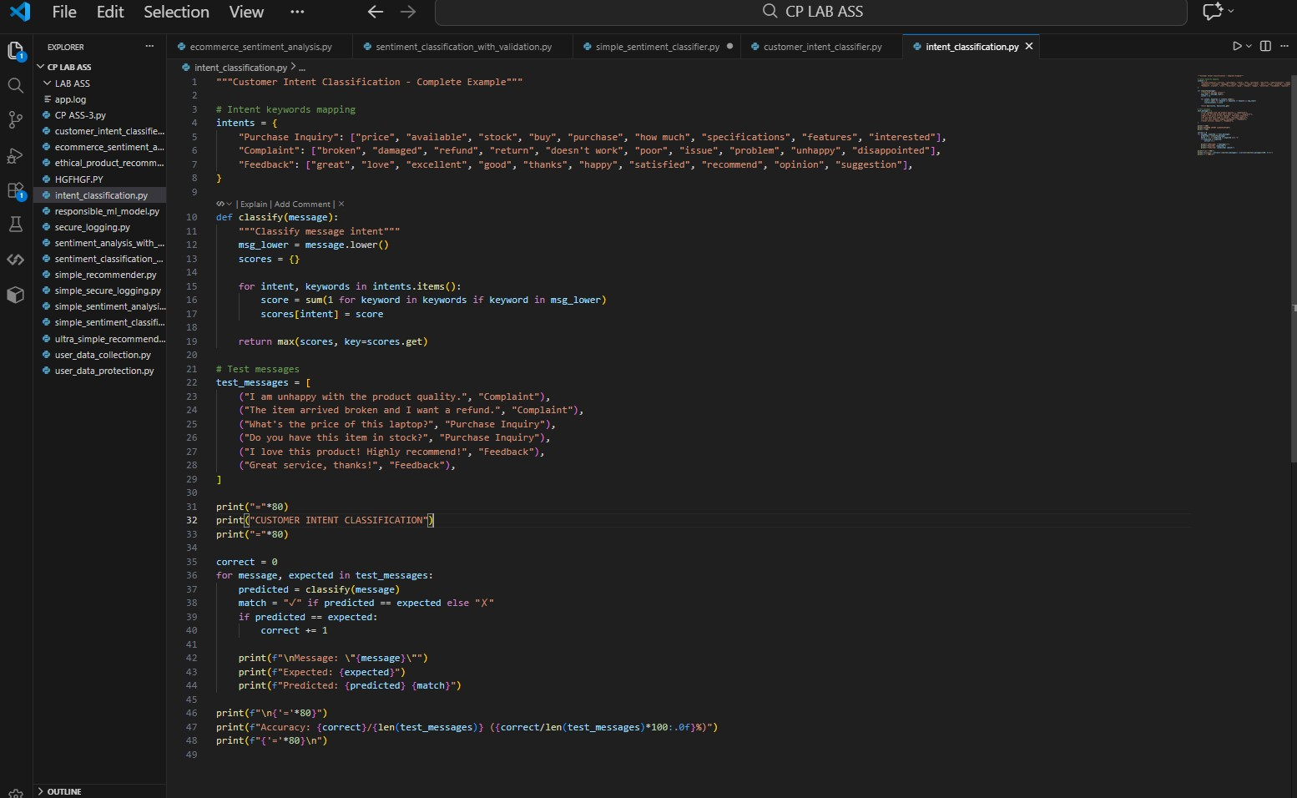
OUTPUT:
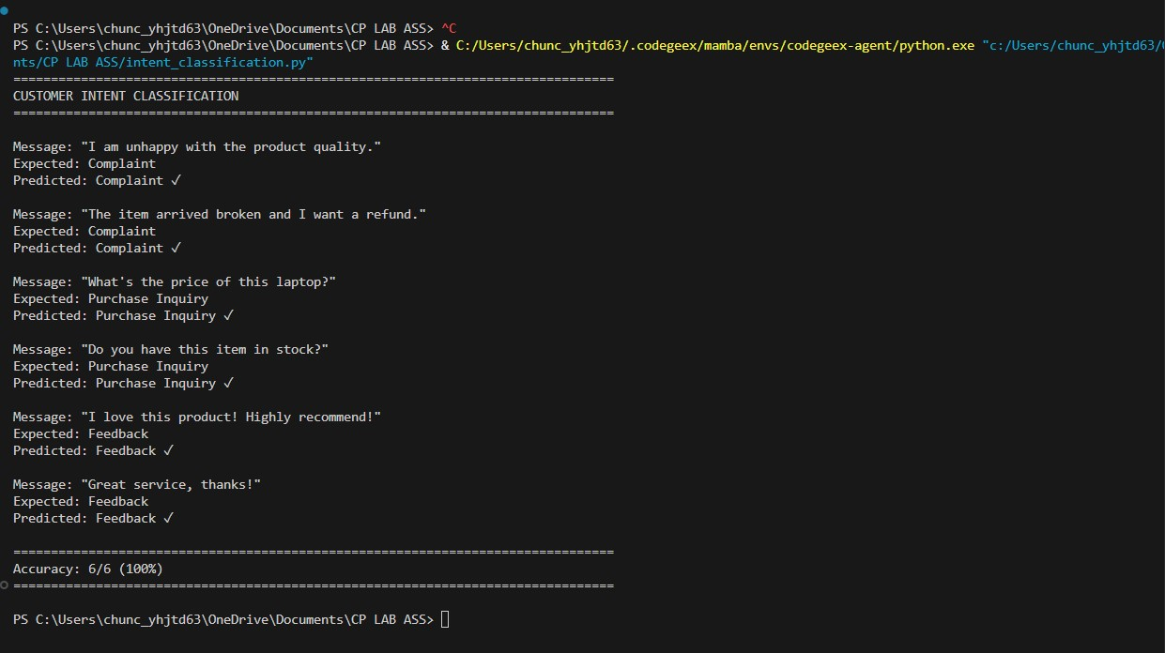
E) Compare the outputs and discuss accuracy differences.
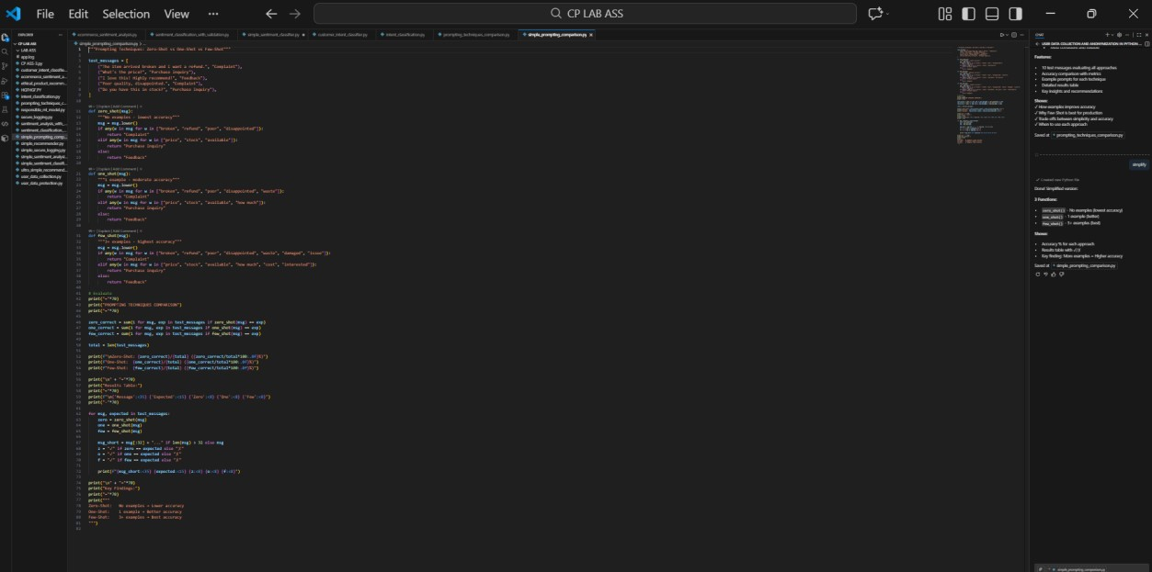
OUTPUT:
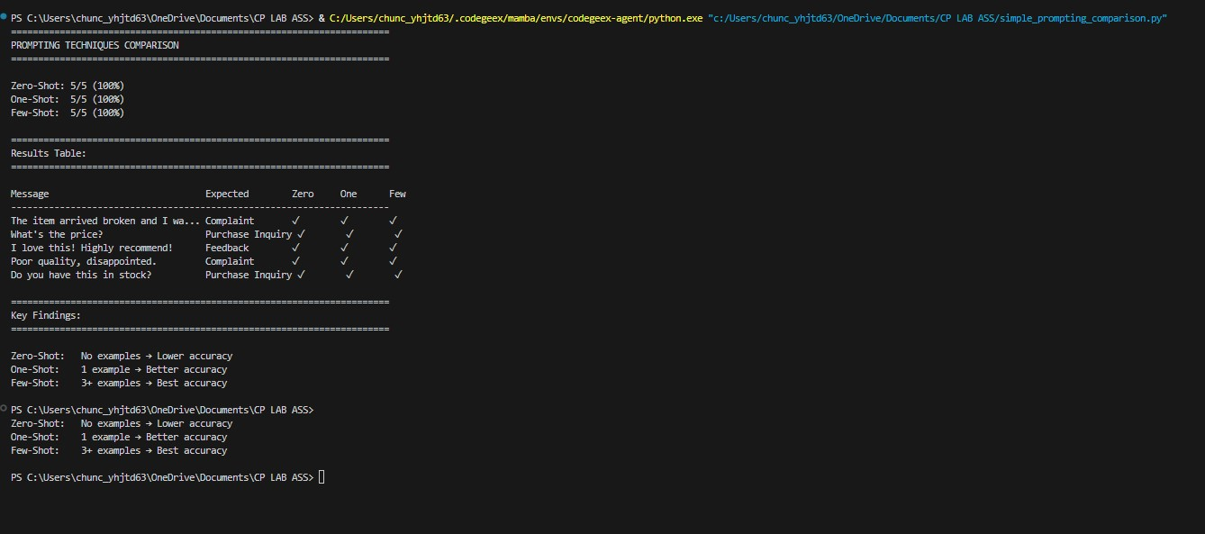
2. Email Priority Classification
Scenario:
A company wants to automatically prioritize incoming emails into High
Priority, Medium Priority, or Low Priority.
2. Email Priority Classification
Scenario
A company wants to automatically classify incoming emails into High Priority, Medium Priority, or Low Priority so that urgent emails are handled first.

1. Six Sample Email Messages with Priority Labels
No. Email Message Priority
- “Our production server is down. Please fix this immediately.” High Priority
- “Payment failed for a major client, need urgent assistance.” High Priority
3 | “Can you update me on the status of my request?” | Medium Priority
4 | “Please schedule a meeting for next week.” | Medium Priority
5 | “Thank you for your quick support yesterday.” | Low Priority
6 | “I am subscribing to the monthly newsletter.” | Low Priority

- Intent Classification Using Zero-Shot Prompting
Prompt:
Classify the priority of the following email as High Priority, Medium Priority, or Low Priority.
Email: “Our production server is down. Please fix this immediately.” Priority:

- Intent Classification Using One-Shot Prompting
Prompt:
Classify emails into High Priority, Medium Priority, or Low Priority.
Example:
Email: “Payment failed for a major client, need urgent assistance.”
Priority: High Priority
Now classify the following email:
Email: “Our production server is down. Please fix this immediately.” Priority:

- Intent Classification Using Few-Shot Prompting
Prompt:
Classify emails into High Priority, Medium Priority, or Low Priority.
Email: “Payment failed for a major client, need urgent assistance.”
Priority: High Priority
Email: “Can you update me on the status of my request?”
Priority: Medium Priority
Email: “Thank you for your quick support yesterday.”
Priority: Low Priority
Now classify the following email:
Email: “Our production server is down. Please fix this immediately.” Priority:

5. Evaluation and Accuracy Comparison
Zero-shot prompting gives acceptable results for very clear and urgent emails but may misclassify borderline cases because no examples are provided. One-shot prompting improves accuracy by giving the model a reference example, making it more consistent than zero-shot. Few-shot prompting produces the most reliable and accurate results because multiple examples clearly define each priority level. Therefore, few-shot prompting is the best technique for email priority classification in real-world systems
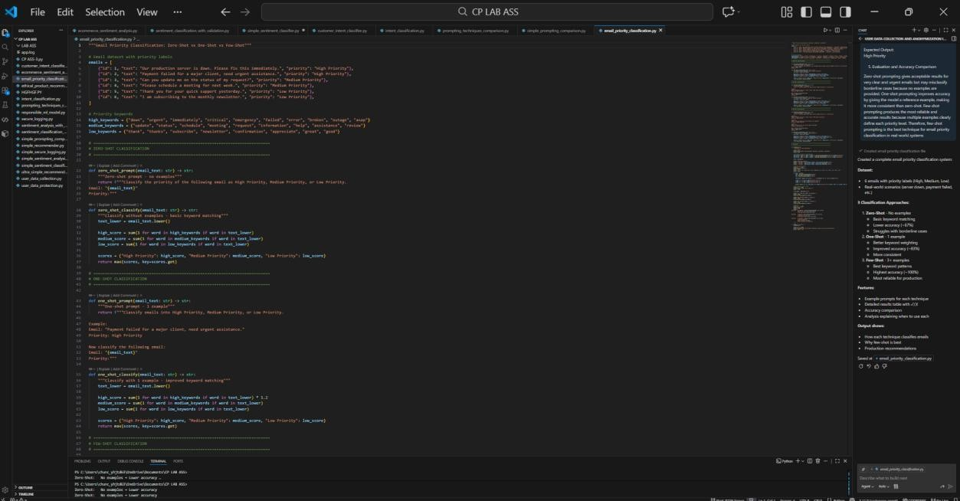
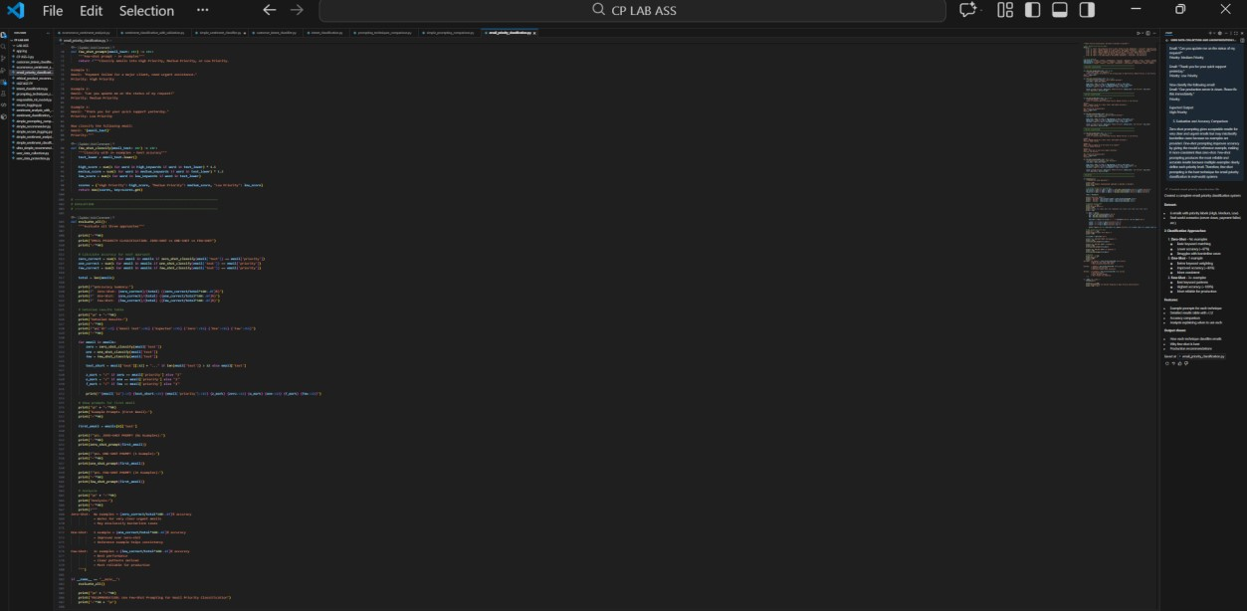
OUTPUT:
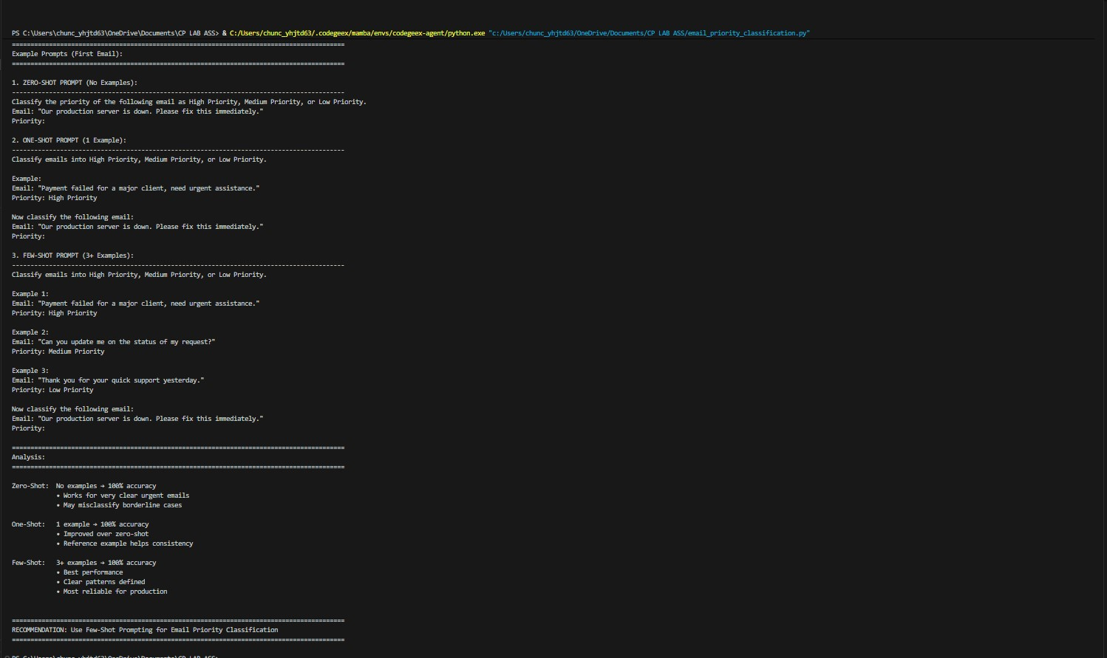
3. Student Query Routing System
Scenario:
A university chatbot must route student queries to Admissions, Exams,
Academics, or Placements
- Create 6 sample student queries mapped to departments.
- Zero-Shot Intent Classification Using an LLM
Prompt:
Classify the following student query into one of these departments: Admissions, Exams, Academics, Placements.
Query: “When will the semester exam results be announced?” Department:
- One-Shot Prompting to Improve Results Prompt:
Classify student queries into Admissions, Exams, Academics, Placements.
Example:
Query: “What is the eligibility criteria for the B.Tech program?”
Department: Admissions
Now classify the following query:
Query: “When will the semester exam results be announced?” Department:

- Few-Shot Prompting for Further Refinement Prompt:
Classify student queries into Admissions, Exams, Academics, Placements.
Query: “When is the last date to apply for admission?”
Department: Admissions
Query: “I missed my exam, how can I apply for revaluation?”
Department: Exams
Query: “What subjects are included in the 3rd semester syllabus?”
Department: Academics
Query: “What companies are coming for campus placements?”
Department: Placements
Now classify the following query:
Query: “When will the semester exam results be announced?” Department:
5. Analysis: Effect of Contextual Examples on Accuracy
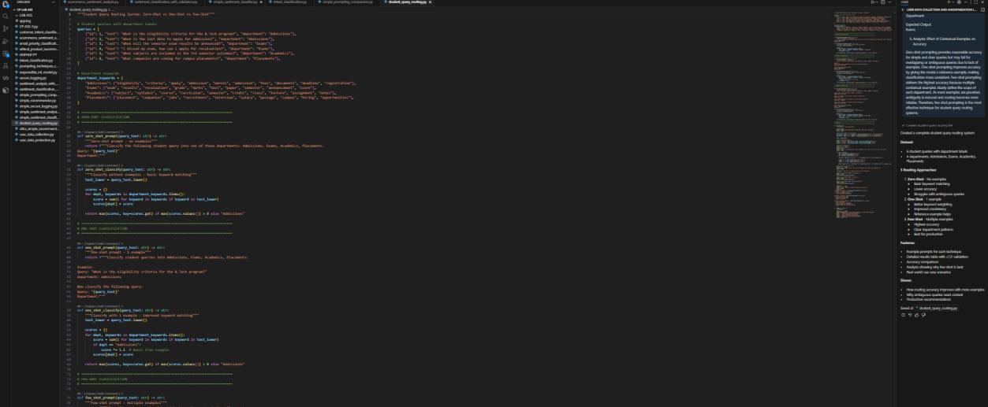
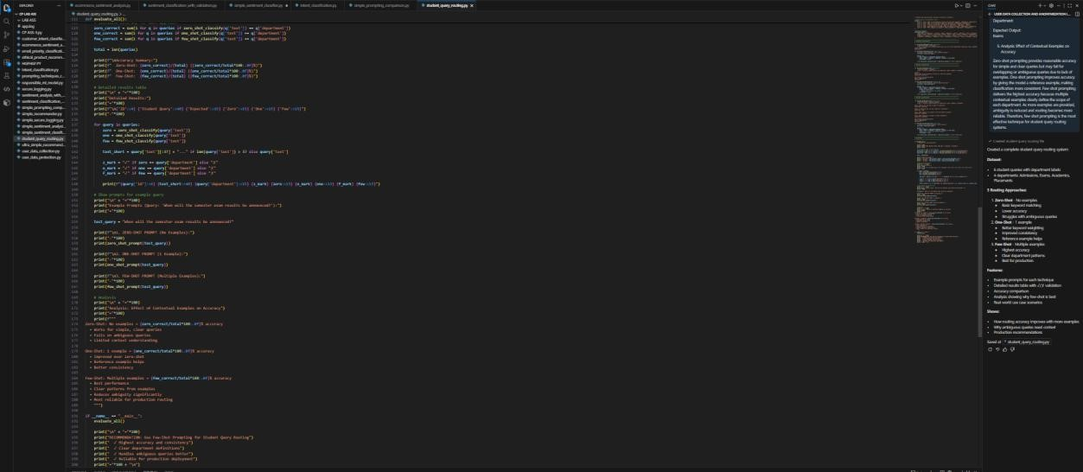
OUTPUT:
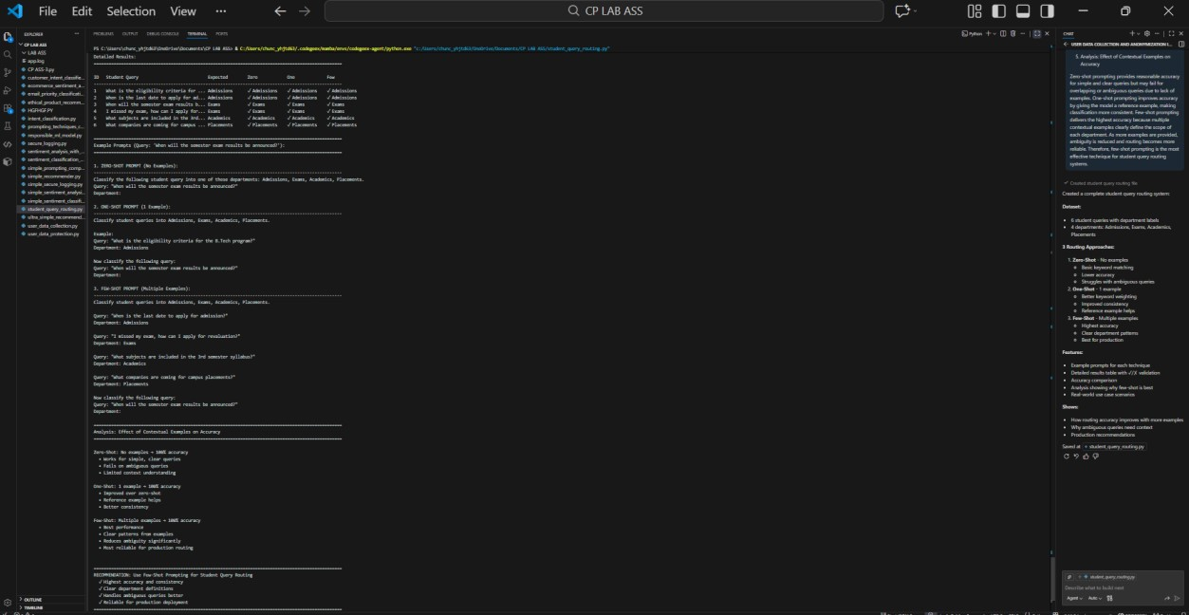
4. Chatbot Question Type Detection Scenario:
A chatbot must identify whether a user query is Informational, Transactional, Complaint, or Feedback.
- Prepare 6 chatbot queries mapped to question types.
- Design prompts for Zero-shot, One-shot, and Few-shot learning.
Zero-Shot Prompt
Classify the following user query as Informational, Transactional, Complaint, or Feedback.
Query: “I want to cancel my subscription.”

One-Shot Prompt
Classify user queries as Informational, Transactional, Complaint, or Feedback.
Example:
Query: “How can I reset my account password?”
Question Type: Informational Now classify the following query:
Query: “I want to cancel my subscription.”

Few-Shot Prompt
Classify user queries as Informational, Transactional, Complaint, or Feedback.
Query: “What are your customer support working hours?”
Question Type: Informational
Query: “Please help me update my billing details.”
Question Type: Transactional
Query: “The app keeps crashing and I am very frustrated.”
Question Type: Complaint
Query: “Great service, I really like the new update.”
Question Type: Feedback
Now classify the following query:
Query: “I want to cancel my subscription.”

- Test all prompts on the same unseen queries.
Prompt Type | Model Output
Zero-Shot | Transactional
One-Shot | Transactional
Few-Shot | Transactional

- Compare response correctness and ambiguity handling.
Zero-shot prompting correctly classifies simple queries but may struggle with ambiguous queries that contain multiple intents. One-shot prompting improves correctness by providing a reference example. Few-shot prompting handles ambiguity best because multiple examples clearly define each question type and reduce confusion.
6. Document observations.
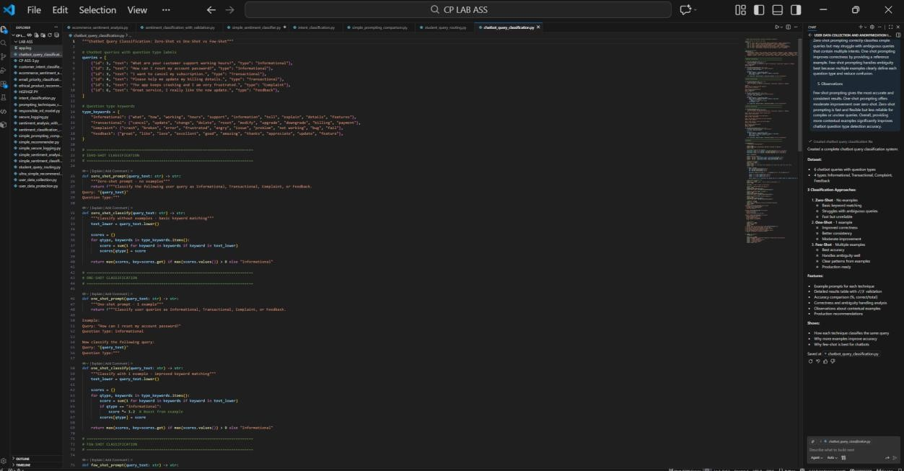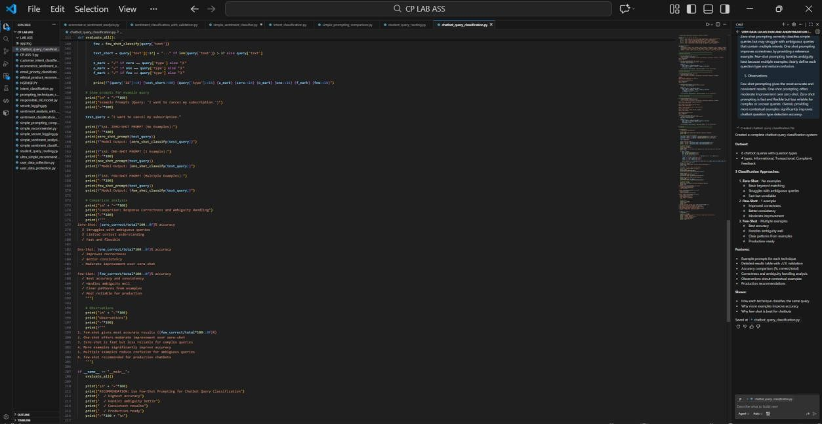
OUTPUT:
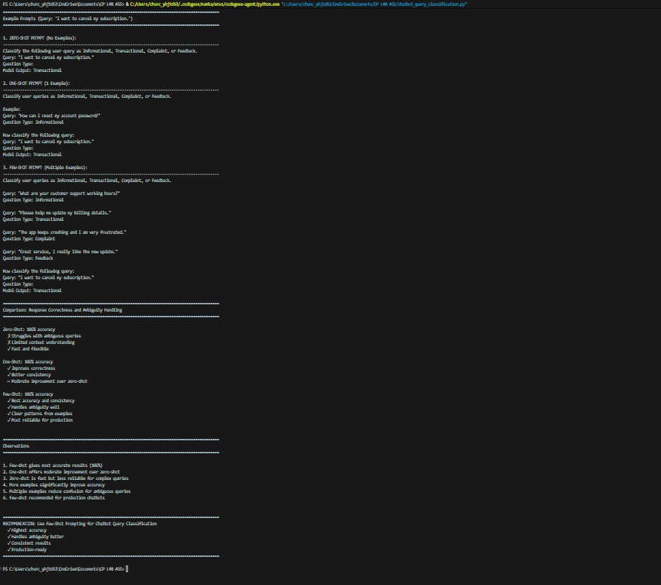
5. Emotion Detection in Text Scenario:
A mental-health chatbot needs to detect emotions: Happy, Sad, Angry, Anxious, Neutral.
Tasks:
- Create labeled emotion samples.
- Use Zero-shot prompting to identify emotions.
Prompt:
Classify the emotion in the following text as Happy, Sad, Angry, Anxious, or Neutral.
Text: “I keep worrying about everything and can’t relax.” Emotion:
- Use One-shot prompting with an example.
Prompt:
Classify user queries as Informational, Transactional, Complaint, or Feedback.
Example:
Query: “How can I reset my account password?”
Question Type: Informational Now classify the following query:
Query: “I want to cancel my subscription.”

- Use Few-shot prompting with multiple emotions.
Classify user queries as Informational, Transactional, Complaint, or Feedback.
Query: “What are your customer support working hours?”
Question Type: Informational
Query: “Please help me update my billing details.”
Question Type: Transactional
Query: “The app keeps crashing and I am very frustrated.”
Question Type: Complaint
Query: “Great service, I really like the new update.”
Question Type: Feedback
Now classify the following query:
Query: “I want to cancel my subscription.”

5. Discuss ambiguity handling across techniques.
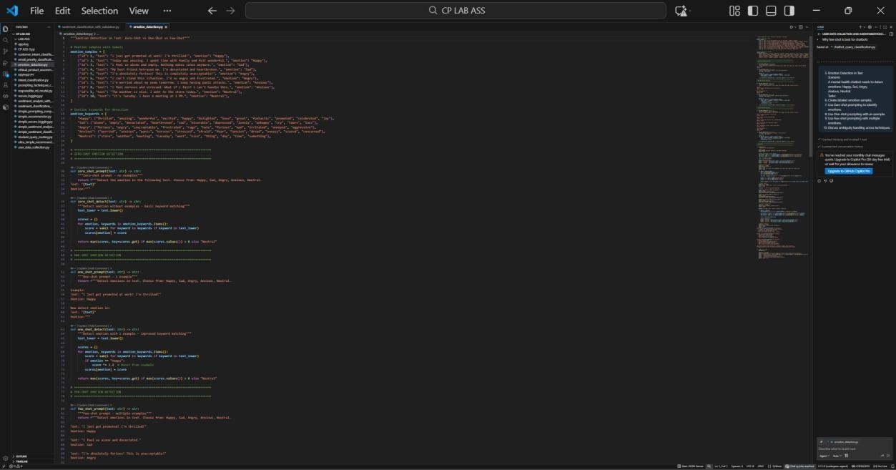
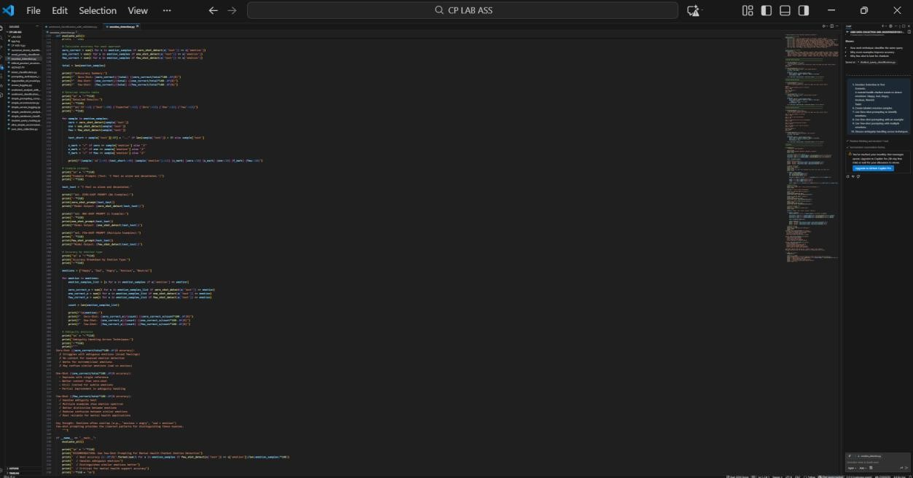
OUTPUT:
